Documentation
Component1
Ranju Sah
Group-B

1.PHP Version 8.0.24
The screenshot of php -v in terminal is given below:-
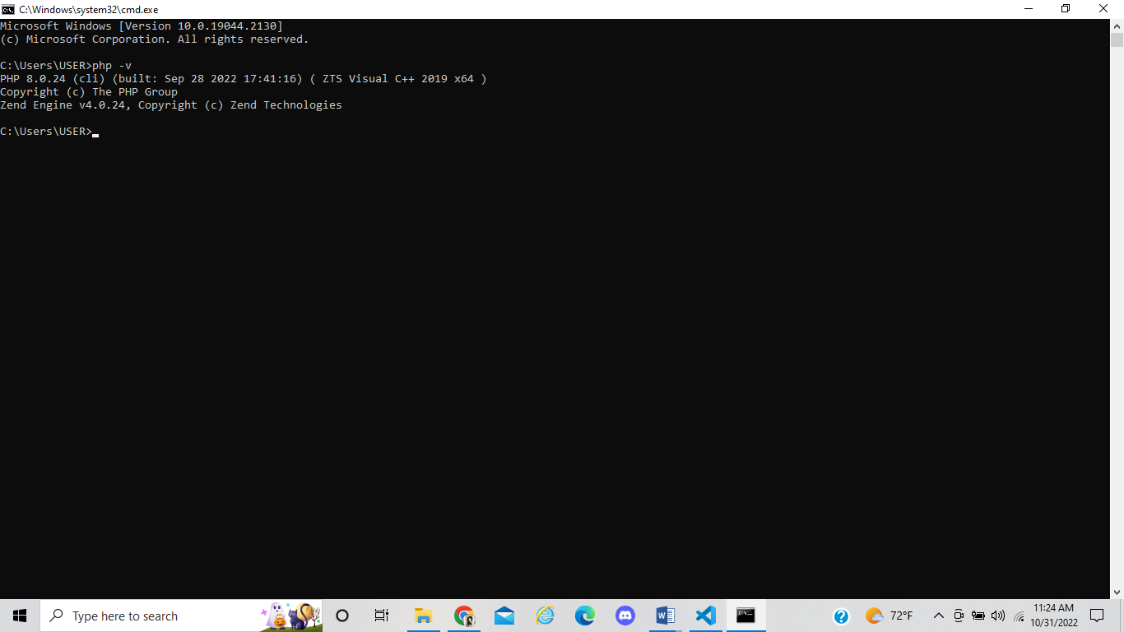

2. IDE of choice/used VSCode
-The screenshot of the IDE with the component 1 project folder is shown
below:-
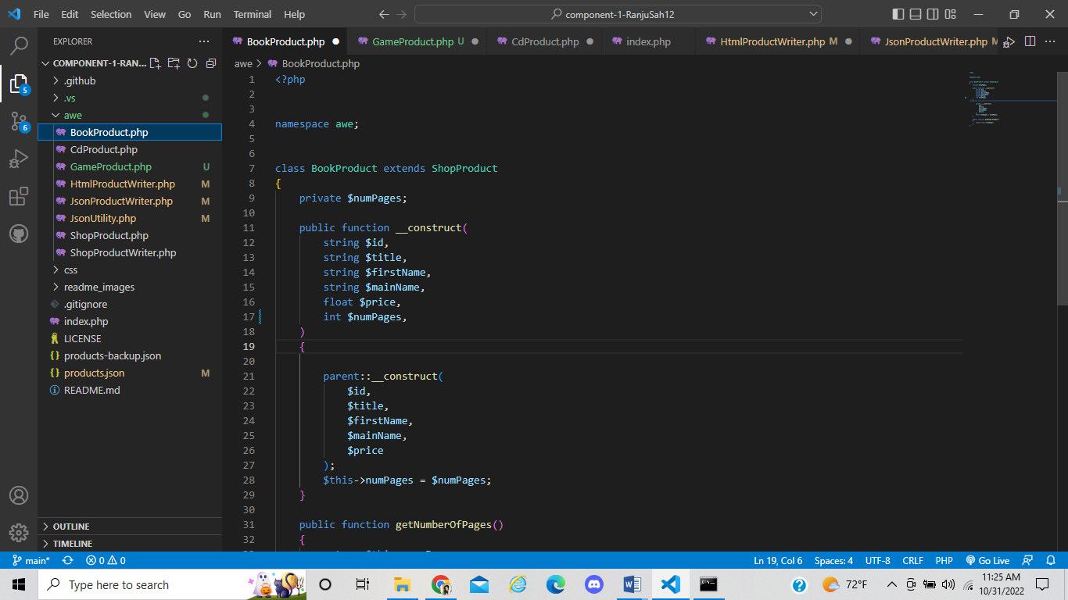

3.Xdebug installed ? Yes or No ?
- Yes, screenshot of Xdebug component active or menu available is
below:-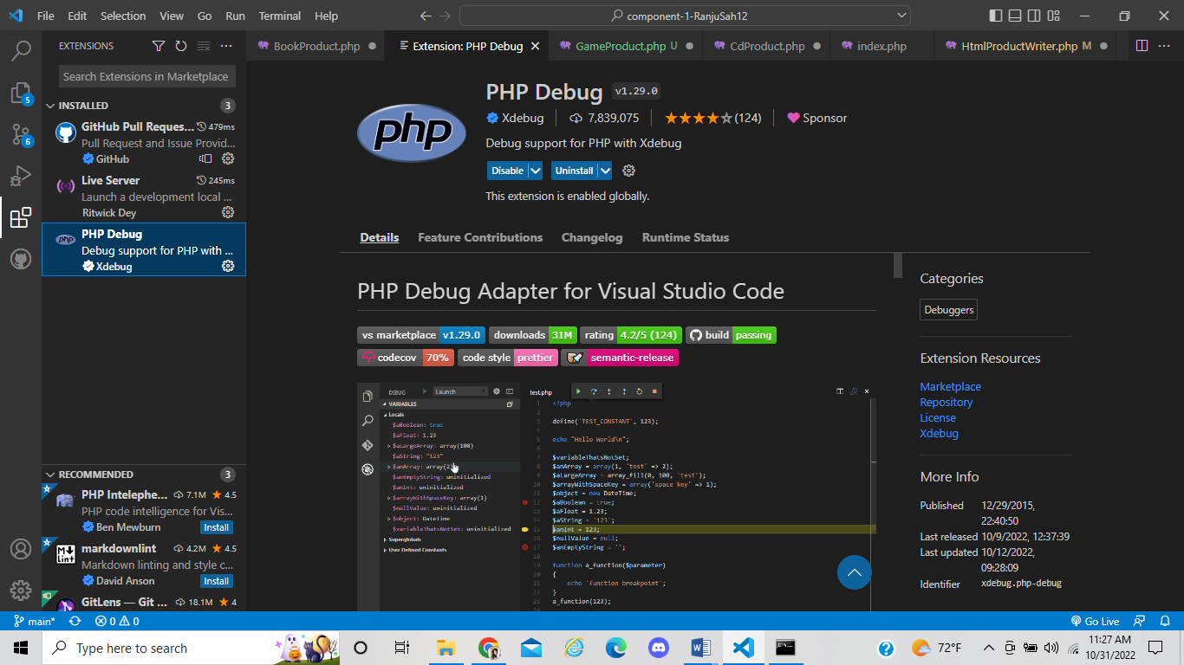

4.Github repo created and cloned ?
-Yes, the link is https://github.com/tbc-bsc-l6/component-1-RanjuSah12.git

5.PHP Exercises done?
-Yes, the following are the screenshots

5.1 Added GameProduct.php
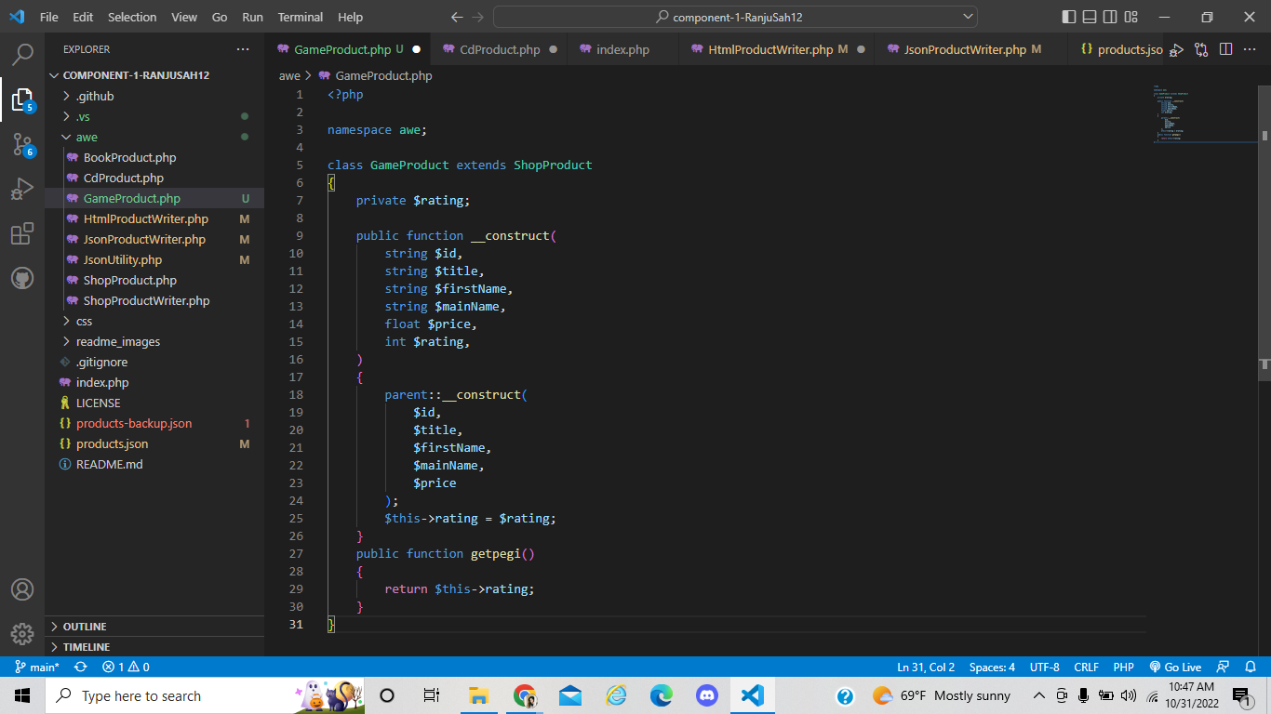

5.2Changes in html product writer
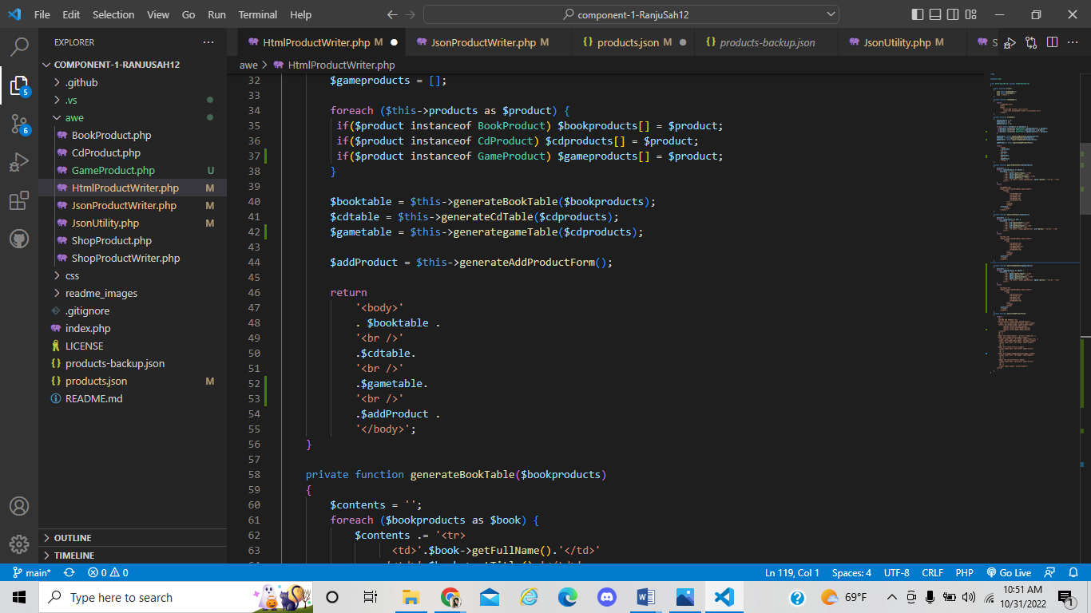
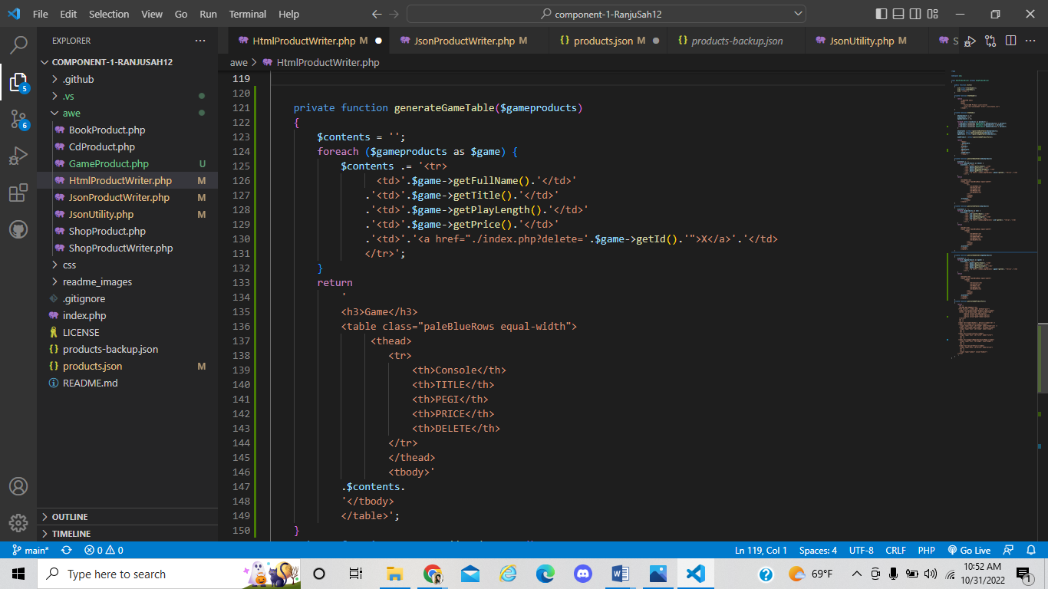

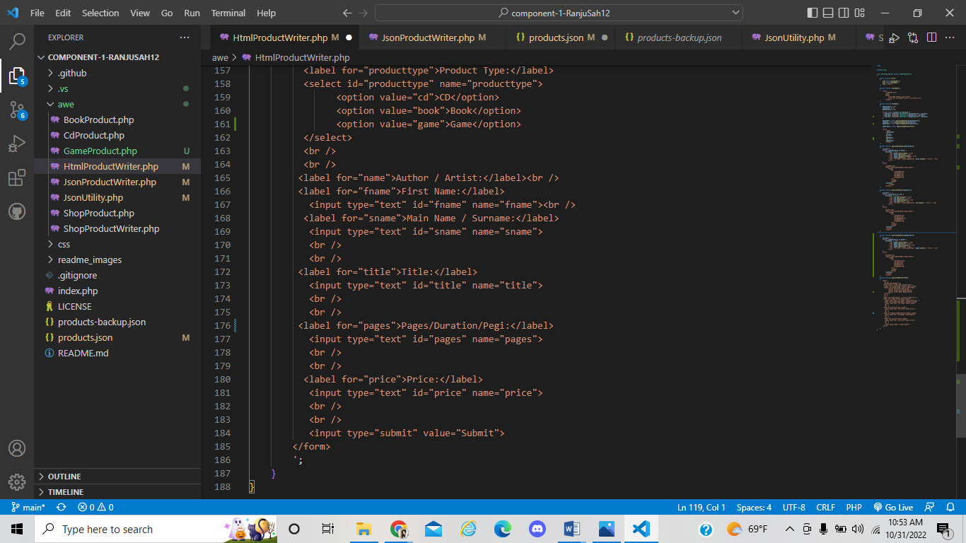

5.3 Changes in json utility 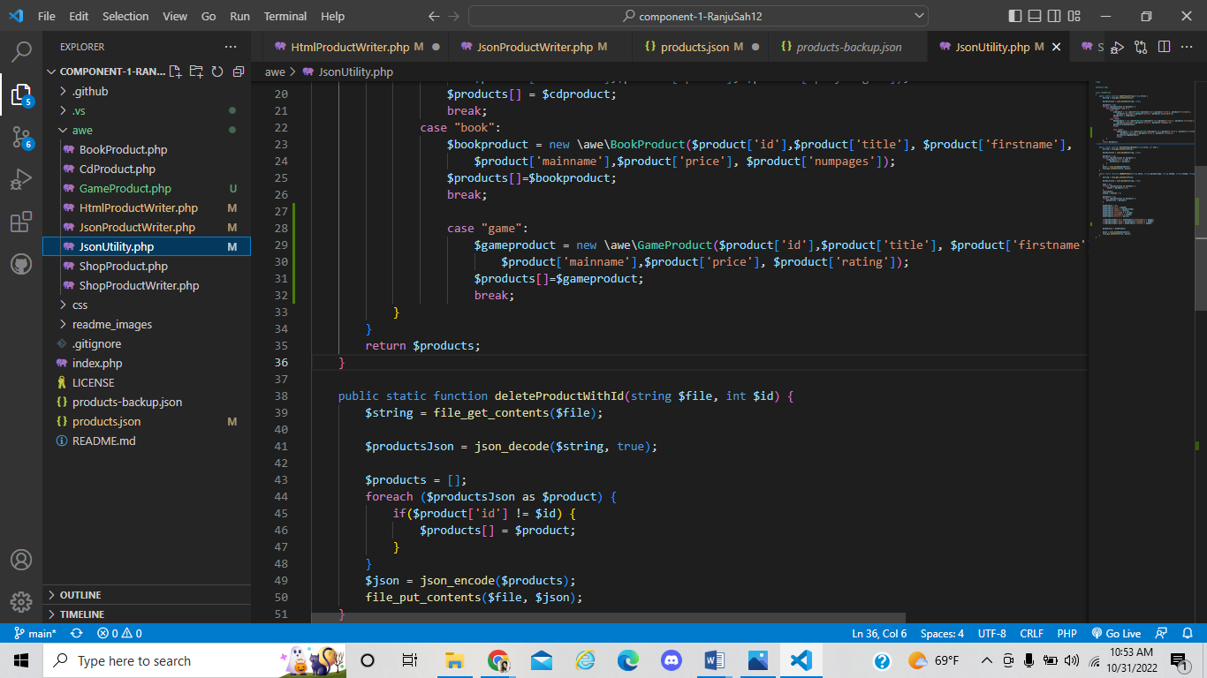

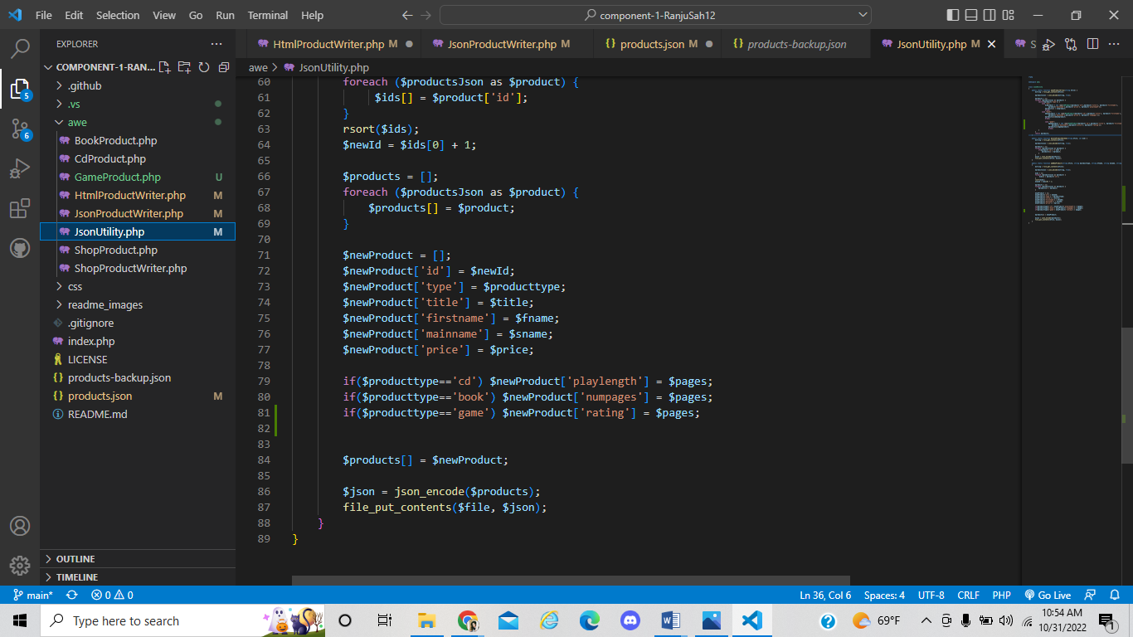

5.4 Changes in product.json
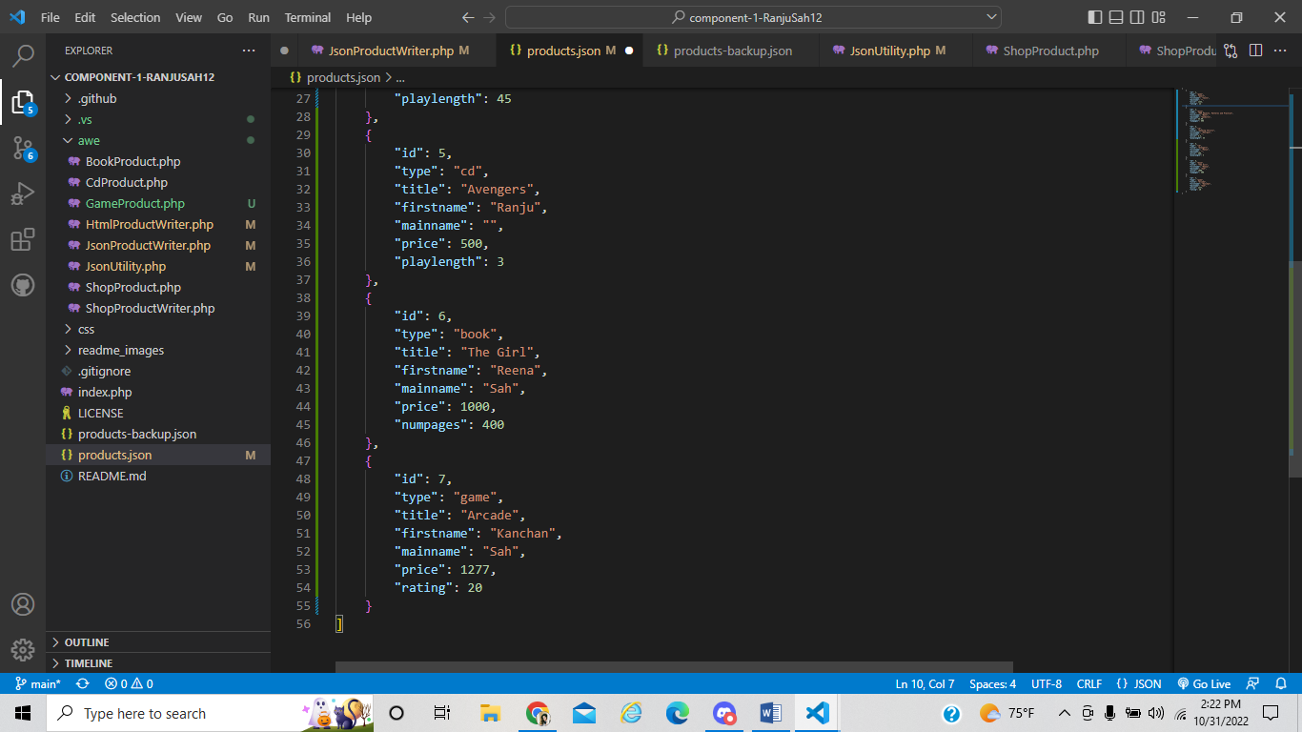

6.Changes In frontend
6.1 Added Game in dropdown menu
